PART 1:

1) ER diagram for the given problem:

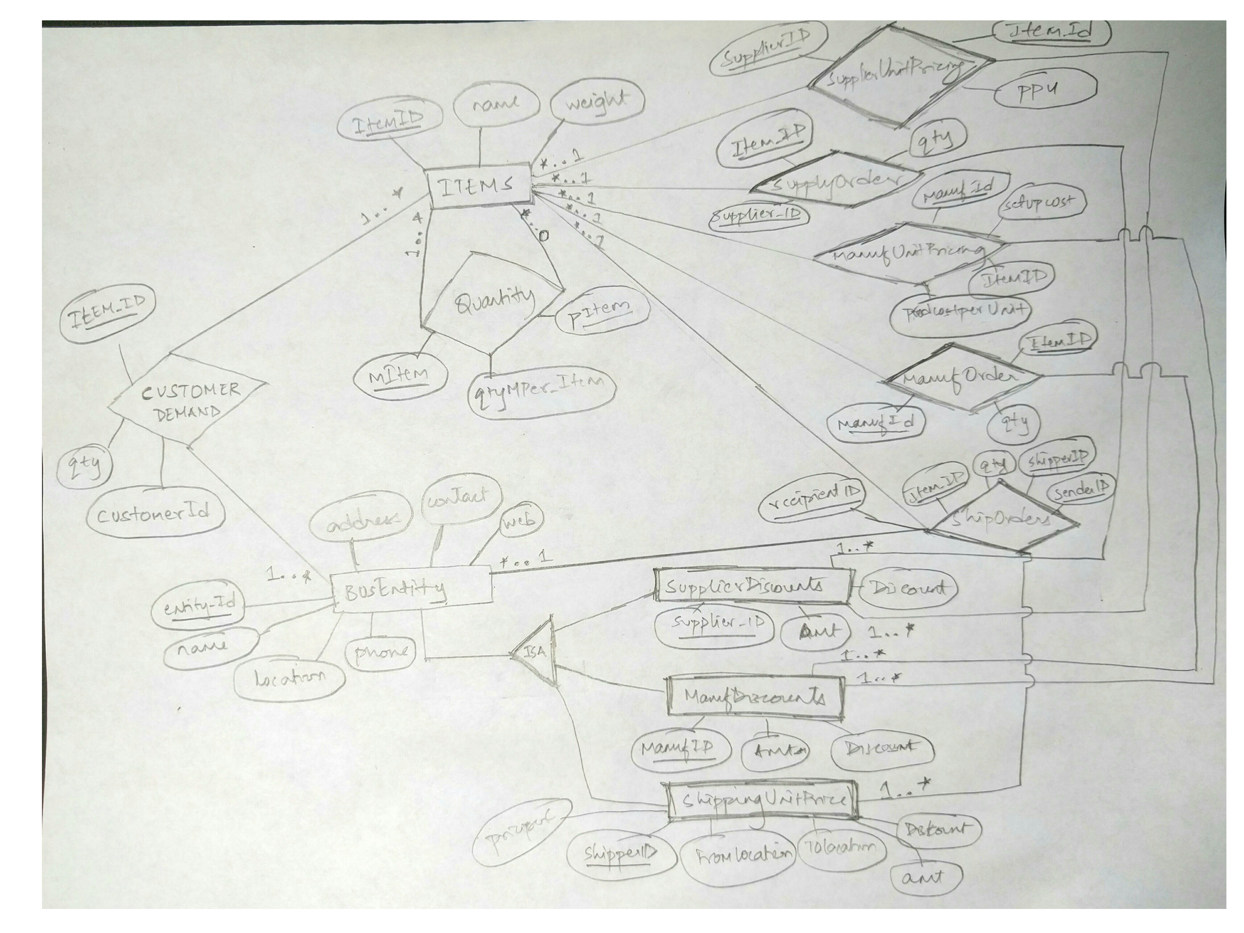

2) create table queries:

The .sql file for these queries are also included.

create table items(

itemid char(20),

weight numeric(7),

name char(20),

primary key (itemid)

);

create table busentities

(

entityid char(20),

location char(20),

address char(20),

phone numeric(10),

web char(20),

contact char(20),

primary key (entityid)

);

create table billofmaterials

(

pitem char(20),

mitem char(20),

qtymperitem integer,

primary key (pitem, mitem),

foreign key (pitem) references items (itemid),

foreign key (mitem) references items (itemid)

);

create table supplierdiscounts

(

supplierid char(20),

amount numeric(7,2),

discount numeric(7,2),

primary key (supplierid),

foreign key (supplierid) references busentities (entityid)

);

create table supplyunitpricing

(

supplierid char(20),

item char(20),

ppu numeric(7,2),

primary key (supplierid, item),

foreign key (supplierid) references supplierdiscounts (supplierid),

foreign key (item) references items (itemid) );

create table manufdiscounts

(

manufid char(20),

amt numeric(7,2),

discount numeric(7,2),

primary key (manufid),

foreign key (manufid) references busentities (entityid)

);

create table manufunitpricing

(

manuf_id char(20),

pitem char(20),

setupcost numeric(7,2),

prodcostperunit numeric(7,2),

primary key (manuf_id, pitem),

foreign key (manuf_id) references manufdiscounts (manufid),

foreign key (pitem) references items (itemid)

);

create table shippingpricing

(

shipperid char(20),

fromloc char(20),

toloc char(20),

minpackageprice numeric(7,2),

priceperlb numeric(7,2),

amt numeric(7,2),

discount numeric(7,2),

primary key (shipperid, fromloc, toloc),

foreign key (shipperid) references busentities (entityid)

);

create table customerdemand

(

customer char(20),

itemid char(20),

qty integer,

primary key (customer, itemid),

foreign key (itemid) references items (itemid),

foreign key (customer) references busentities (entityid)

);

create table supplyorders

(

itemid char(20),

supplierid char(20),

qty integer,

primary key (itemid, supplierid),

foreign key (itemid) references items (itemid),

foreign key (supplierid) references supplierdiscounts (supplierid)

);

create table manuforders

(

itemid char(20),

manufid char(20),

qty integer,

primary key (itemid, manufid),

foreign key (itemid) references items (itemid),

foreign key (manufid) references manufdiscounts (manufid)

);

create table shiporders

(

itemid char(20),

shipperid char(20),

senderid char(20),

recipientid char(20),

qty integer,

primary key (itemid, shipperid, senderid, recipientid),

foreign key (itemid) references items (itemid),

foreign key (senderid) references busentities (entityid),

foreign key (shipperid) references busentities (entityid),

foreign key (recipientid) references busentities (entityid)

);

PART -2 – Creating the Views

/*1*/

create view shippedvscustdemand as

(

select c.item, c.customer, c.qty as demandquantity, coalesce(sum(s.qty), 0) as shippedquantity from customerdemand c

left join shiporders s on s.item = c. item and c.customer = s.recipient

group by c.item, c.customer, c.qty

);

Output for the view’s select statement:

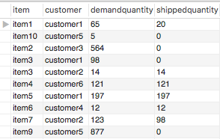

/*2*/

create or replace view totalmanufitems as

(

select item, sum(qty) as totalquantity from manuforders

group by (item)

);

Output for the view’s select statement:

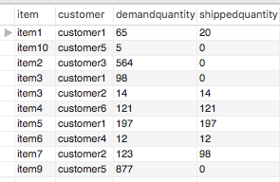

/*3*/

create or replace view temp as

(

select recipient, item, sum(qty) as recievedquantity from shiporders

group by recipient, item

);

create or replace view matusedvsshipped as

(

select m.manuf, m.item, b.matitem, m.qty * b.qtymatperitem as productionquantity, coalesce(a.recievedquantity, 0) as recievedquantity from manuforders m

left join billofmaterials b on m.item = b.proditem

left join temp a on a.recipient = m.manuf and a.item = b.matitem

);

Output for the view’s select statement:

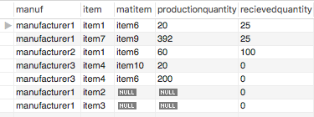

/*4*/

create or replace view temp as

(

select sender, item, sum(qty) as shippedquantity from shiporders

group by sender, item

);

create or replace view producedvsshipped as

(

select m.manuf, m.item, m.qty as productionquantity, coalesce(a.shippedquantity, 0) as shippedquantity from manuforders m

left join temp a on a.sender = m.manuf and a.item = m.item

);

OUTPUT :

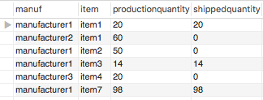

/*5*/

create or replace view suppliedvsshippedtemp as

(

select sender, item, sum(qty) as shippedquantity from shiporders

group by sender, item

);

create or replace view suppliedvsshipped as

(

select s.supplier, s.item, s.qty as orderedquantity, coalesce(a.shippedquantity, 0) as shippedquantity from supplyorders s

left join suppliedvsshippedtemp a on a.sender = s.supplier and a.item = s.item

);

OUTPUT :

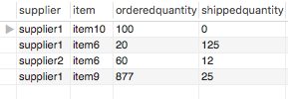

/*6*/

create or replace view persuppliercosttemp as

(

select s.supplier, sum(s.qty * sp.ppu) as totalpricenod

from supplyorders s

left join supplyunitpricing sp on s.supplier = sp.supplier and s.item = sp. item

group by s.supplier

);

create or replace view persuppliercost as

(

select st.supplier,

case when (st.totalpricenod >= sd.amt1 and st.totalpricenod < sd.amt2) then

sd.amt1 + (st.totalpricenod - sd.amt1) * (1 - sd.disc1)

when (st.totalpricenod >= sd.amt2) then

sd.amt1 + (sd.amt2 - sd.amt1) * (1 - sd.disc1)+ (st.totalpricenod - sd.amt2) * (1 - sd.disc2)

else st.totalpricenod

end as finalsuppliercost

from persuppliercosttemp st

left join supplierdiscounts sd on st.supplier = sd.supplier

);

OUTPUT:

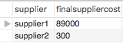

/*7*/

create or replace view permanufcosttemp as

(

select m.manuf, sum((m.qty * mp.prodcostperunit) + mp.setupcost) as totalmanufcostnod

from manuforders m

left join manufunitpricing mp on mp.manuf = m.manuf and mp.proditem = m.item

group by m.manuf

);

create or replace view permanufcost as

(

select mt.manuf,

case when (mt.totalmanufcostnod >= md.amt1) then

md.amt1 + (mt.totalmanufcostnod - md.amt1) * (1 - md.disc1)

else coalesce(mt.totalmanufcostnod, 0)

end as finalmanufcost

from permanufcosttemp mt

left join manufdiscounts md on md.manuf = mt.manuf

);

OUTPUT:

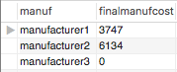

/*8*/

create or replace view pershippercosttemp as

(

select so.shipper, b1.shiploc as fromloc, b2.shiploc as toloc, sum(qty * i.unitweight) as totalweight

from shiporders so

left join busentities b1 on so.sender = b1.entity

left join busentities b2 on so.recipient = b2.entity

left join items i on i.item = so.item

group by so.shipper, b1.shiploc, b2.shiploc

);

create or replace view pershippercosttemp2 as

(

select sp.shipper, sp.fromloc, sp.toloc, sp.minpackageprice,

case when (t.totalweight * sp.priceperlb >= sp.amt1 and t.totalweight * sp.priceperlb < sp.amt2) then sp.amt1 + ((t.totalweight * sp.priceperlb) - sp.amt1) * (1 - sp.disc1)

when (t.totalweight * sp.priceperlb >= sp.amt2) then

sp.amt1 + (sp.amt2 - sp.amt1) * (1 - sp.disc1) + ((t.totalweight * sp.priceperlb) - sp.amt2) * (1 - sp.disc2)

else t.totalweight * sp.priceperlb

end as discountedcost

from shippingpricing sp

left join pershippercosttemp t on sp.shipper = t. shipper and sp.fromloc = t.fromloc and sp.toloc = t.toloc

);

create or replace view pershippercosttemp3 as

(

select st.shipper,

case when (st.minpackageprice > st.discountedcost) then st.minpackageprice

else st.discountedcost

end as totalprice

from pershippercosttemp2 st

);

create or replace view pershippercost as

(

select shipper, sum(totalprice) as totalshippingcost

from pershippercosttemp3

group by(shipper)

);

OUTPUT:

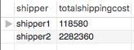

/*9*/

create or replace view temp1 as(

select coalesce(sum(finalsuppliercost),0) as totalsupplycost from persuppliercost

);

create or replace view temp2 as(

select coalesce(sum(finalmanufcost), 0) as totalmanufcost from permanufcost

);

create or replace view temp3 as(

select coalesce(sum(totalshippingcost), 0) as totalshippingcost from pershippercost

);

create or replace view totalCostBreakdown as(

select totalsupplycost, totalmanufcost, totalshippingcost, totalsupplycost + totalmanufcost + totalshippingcost as OverallCost

from temp1,temp2,temp3

);

OUTPUT:

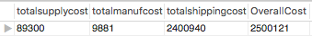

**PART 2.C**

**SQL QUERIES:**

/*1*/

select * from shippedVsCustDemand where demandquantity > shippedquantity;

OUTPUT:

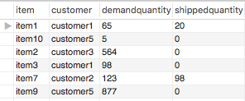

/*2*/

select * from suppliedVsShipped where orderedquantity > shippedquantity;

OUTPUT:

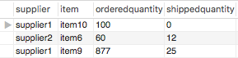

/*3*/

select * from matUsedVsShipped where productionquantity > recievedquantity;

OUTPUT:

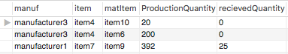

/*4*/

select * from producedVsShipped where productionQuantity > shippedQuantity;

OUTPUT:

